Launch an EC2 instance (Linux and Windows) along with a web server. Then, create an EBS volume of 5 GB, attach it to an EC2 machine (Linux and Windows), and take a snapshot. Finally, create an EBS volume using the taken

First, we are going to launch the EC2 instances:

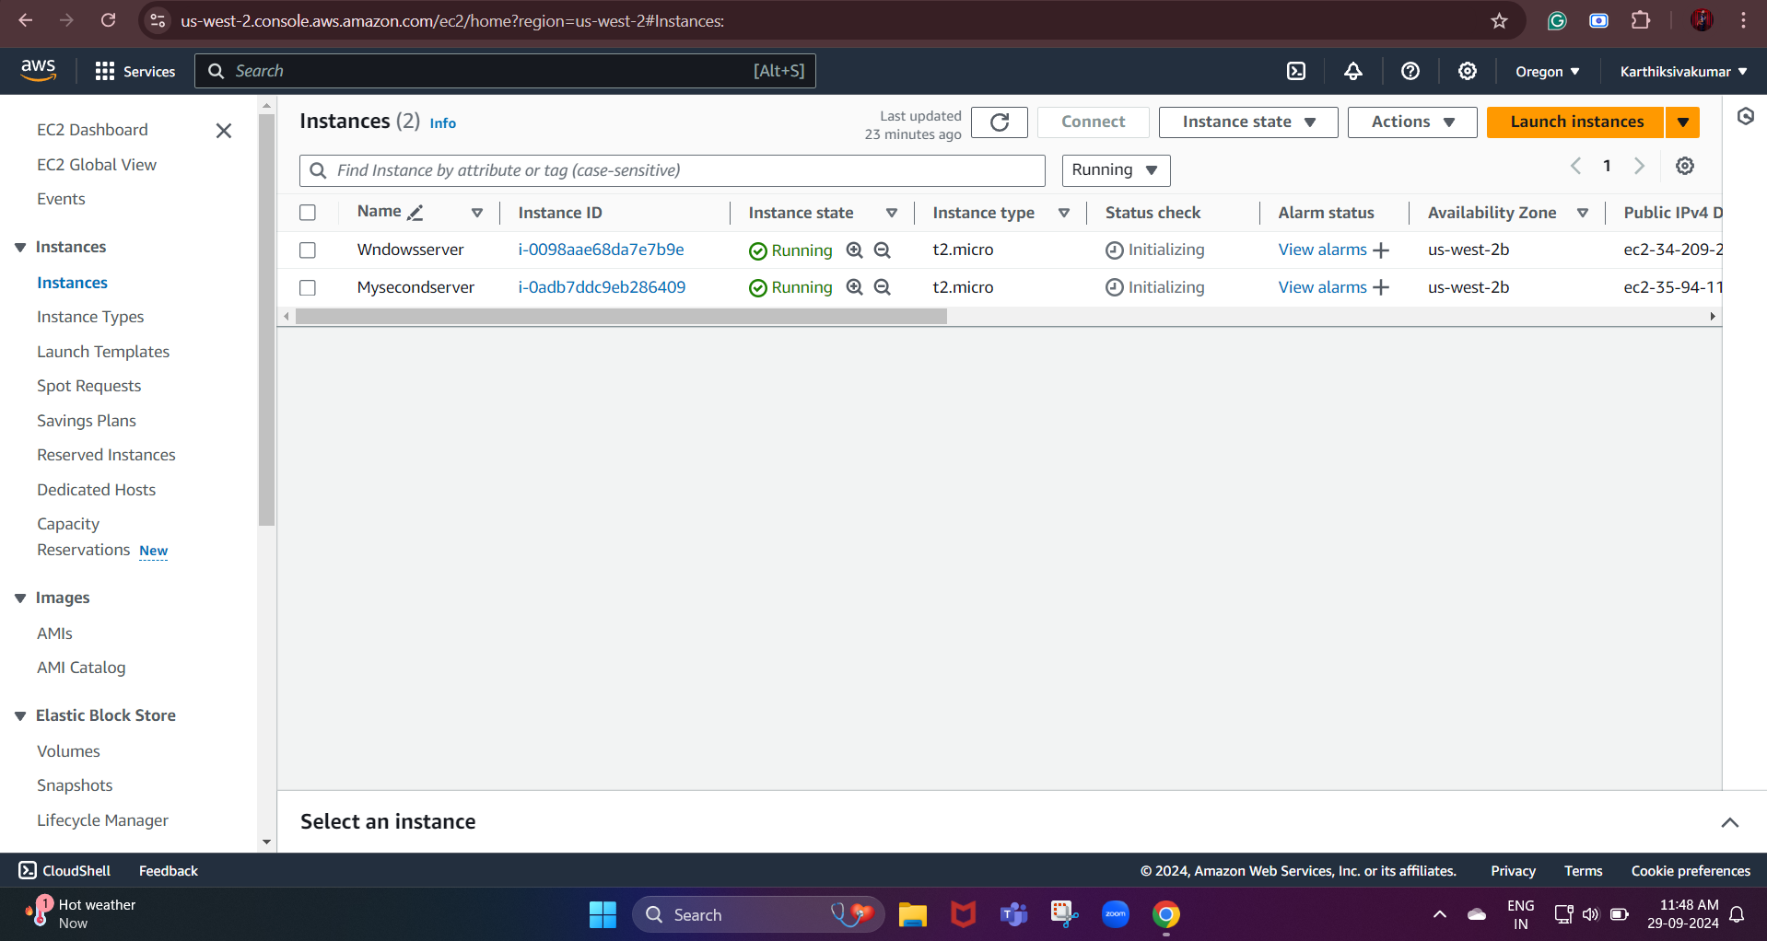

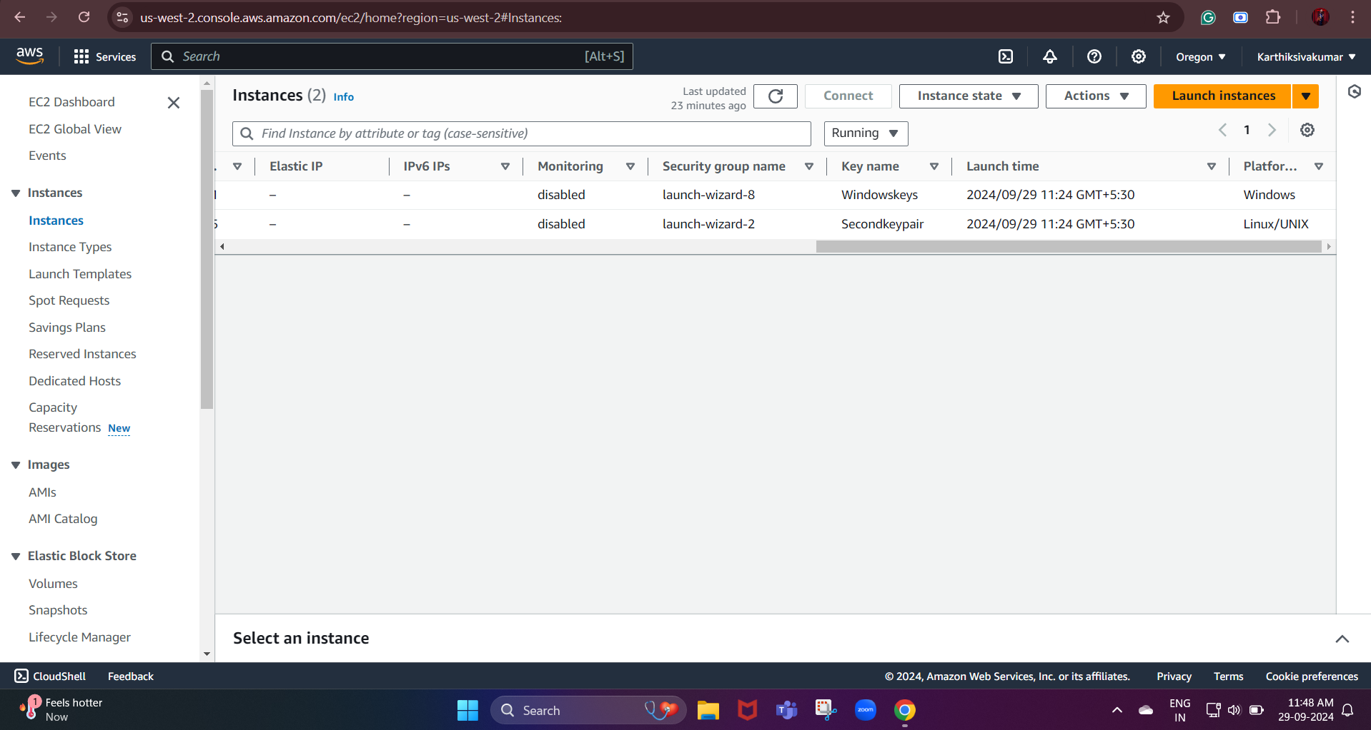

Create a new security group or use an existing one.

Allow HTTP (port 80) and SSH (port 22) access.

This should be followed in both of the created services.

Next, we need to create an EBS volume:

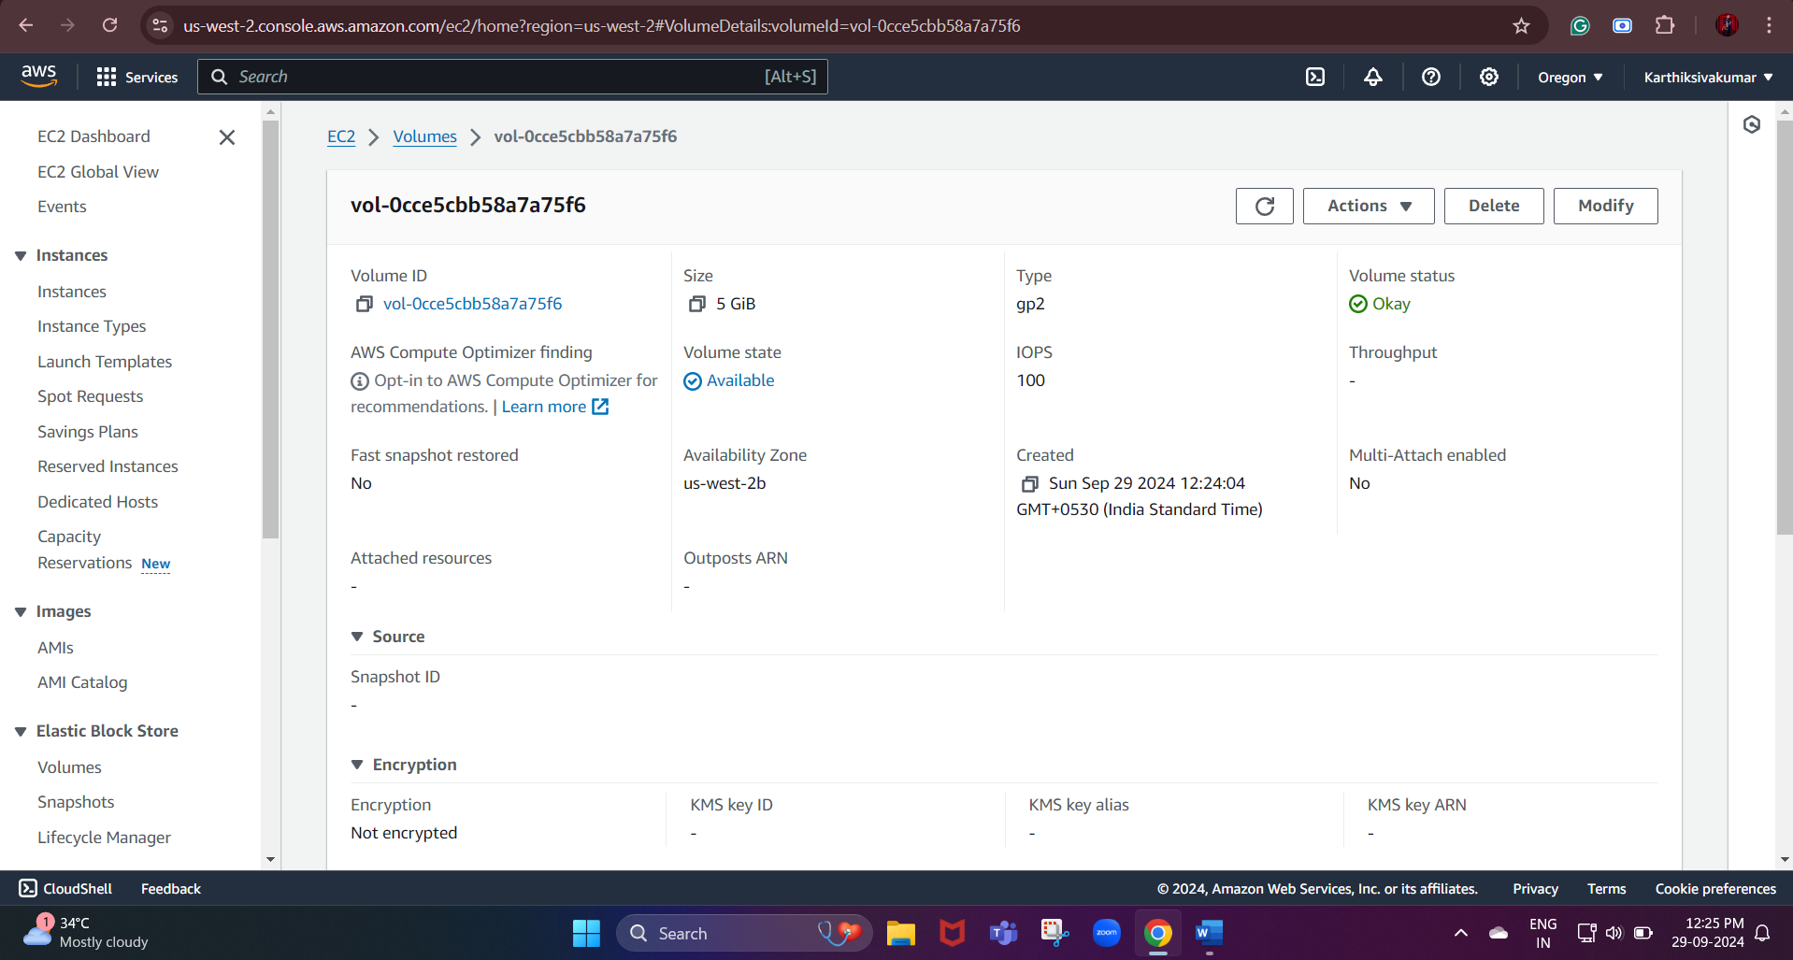

Now, we created the volume next we need to attach this volume to our instance.

Linux server:

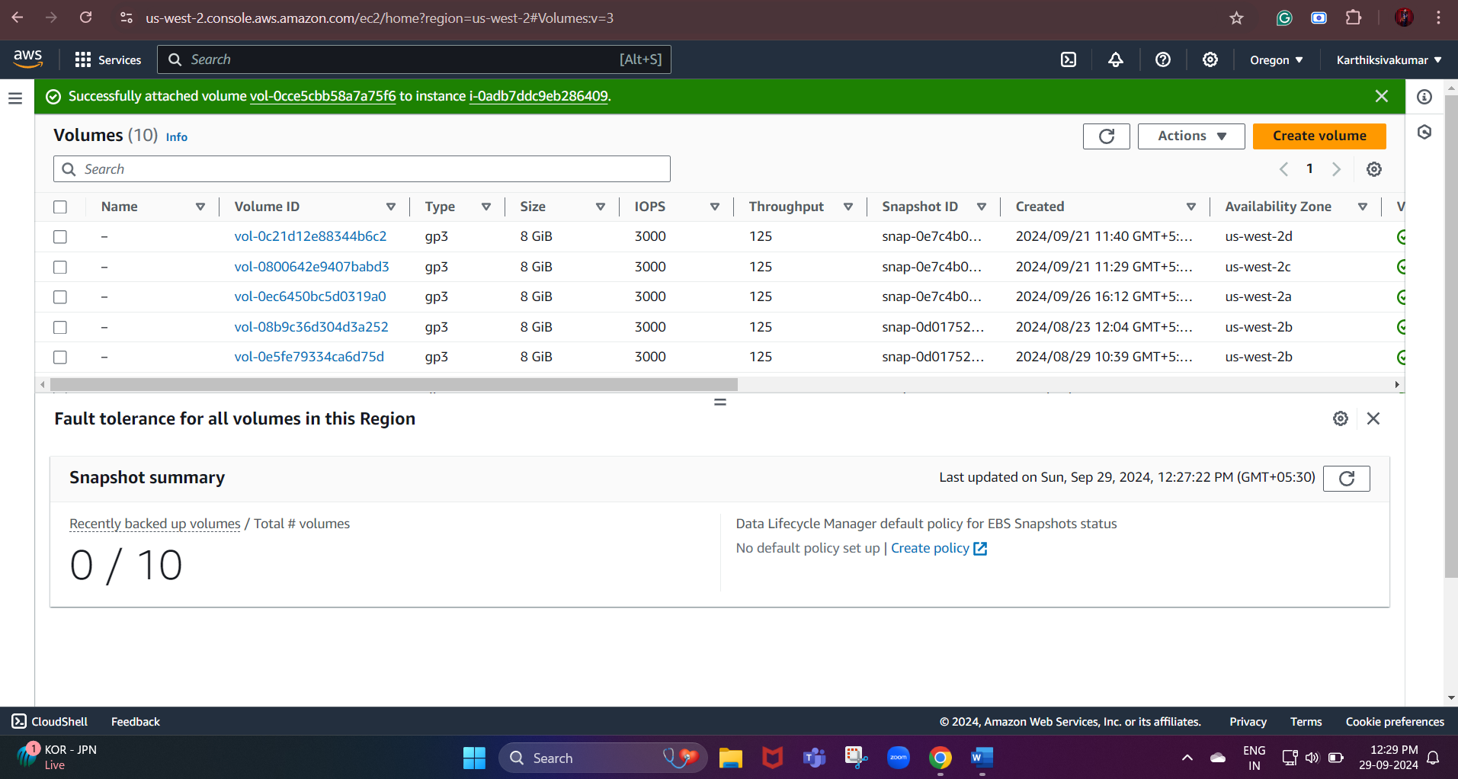
Set the device name (usually /dev/sdf or /dev/xvdf).

Windows server:

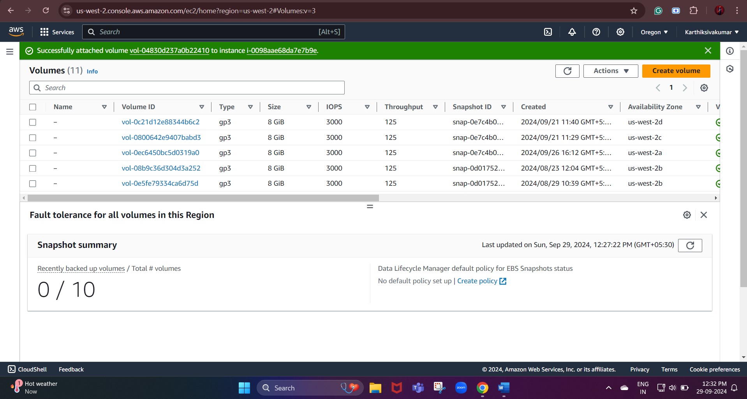

Set the device name (usually xvdf or xvdg)

Create a Snapshot of the EBS Volume

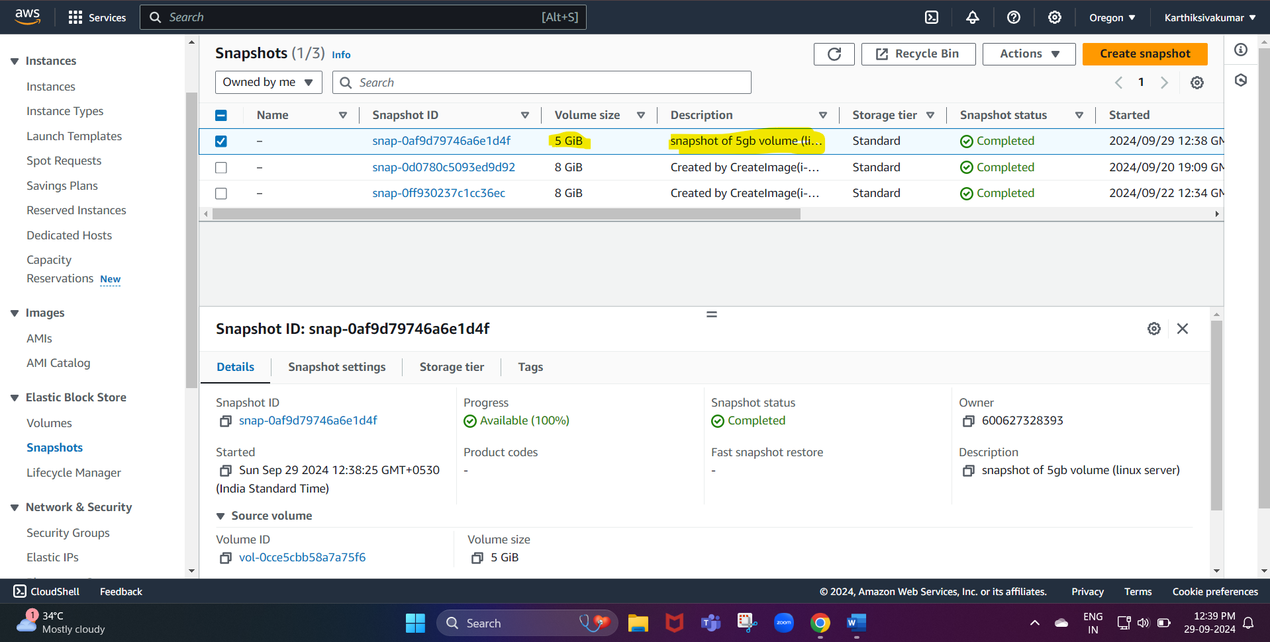

Here we can see our snapshot of our created volume

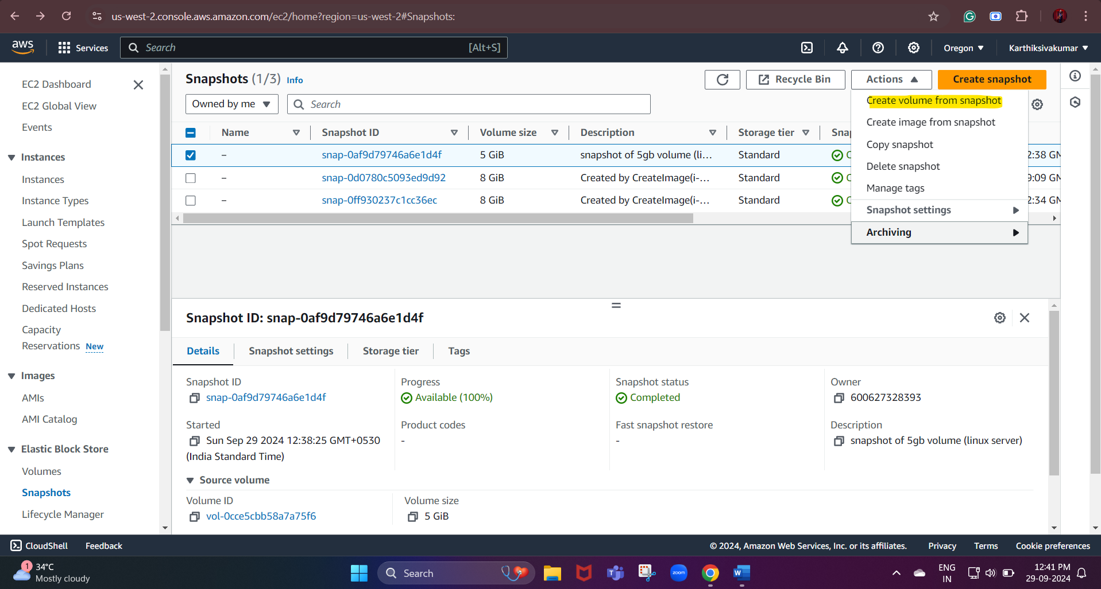

After selecting the snapshot we created

- We need to click the actions
- Then we need to select the create volume from the snapshot
- By doing this, we can create another volume from the snapshot we created

- We can specify the space size if need it can be the same or larger

